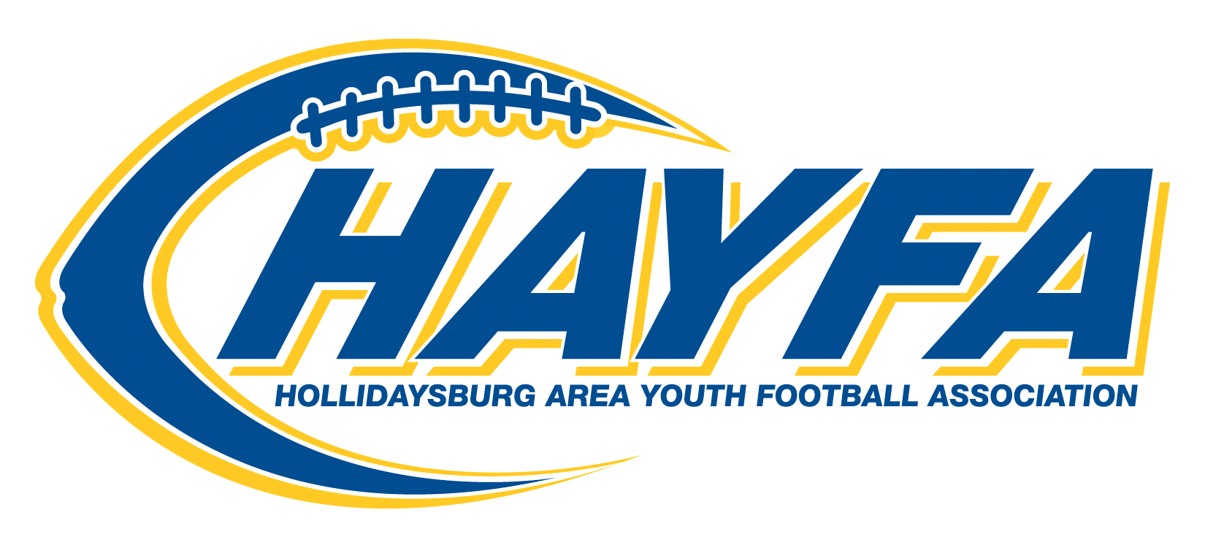

**2022 HAYFA Calendar of Events**

July 10th Sunday Night Conditioning & Agility (Optional)

Location: Tiger Stadium Time: 6:30 PM to 8:00 PM

July 18th -21st Coach Delattre's Youth Camp Tiger Stadium

July 30th 6th Grade Football Equipment Distribution

Location: Baseball Building Time: 9:00 AM to 11:00 AM

July 30th 4th & 5th Grade Football Equipment Distribution

Location: Baseball Building Time: 11 AM to 2 PM

August TBD Cheerleader Uniform Handouts

August 1st to 4th **HAYFA Football Camp** Tiger Stadium 7:00 PM to 8:45 PM

August 1st - Parent Mandatory Meeting @ Tiger Stadium 7:00 PM

August 5th Team Announcements Tiger Stadium 6:30 PM

August 8th Team Practices Begin Locations & Time TBD

August 9th/10th Team Pictures Tiger Stadium Time: TBD

August 12th GTFA Pig Roast (Golden Tiger Football Association/Hollidaysburg Football)

August 20th Tiger Pride Day Tiger Stadium - HAYFA scrimmages 3:30 PM to 6:00 PM

August 27th Opening Day – Games Begin Tiger Stadium 1:00 PM

Sept 16th HAYFA Night @ Varsity Game Location: Tiger Stadium

October 7th Hollidaysburg Area Homecoming Events – HAYFA in Parade

October 8th 3rd Annual HAYFA Salute to Service Games

October 26th Blue & White Game (Future Tiger Bowl) 6th graders only

October 23rd HAYFA Year End Banquet Location: Casino at Lakemont, Time: 1:00-3:00 PM

Dates and times are subject to change. Be sure to check the website for a current calendar of events